**Buy Verified Revolut Account from USABUYSMM.COM**

**Introduction to Revolut and Its Growing Popularity**

Revolut has become a global fintech sensation, offering digital banking solutions that allow users to manage multiple currencies, send money abroad, and track their spending—all from a single mobile app. As of 2025, its user base has exploded, with more individuals and businesses relying on Revolut for secure, flexible, and borderless banking.

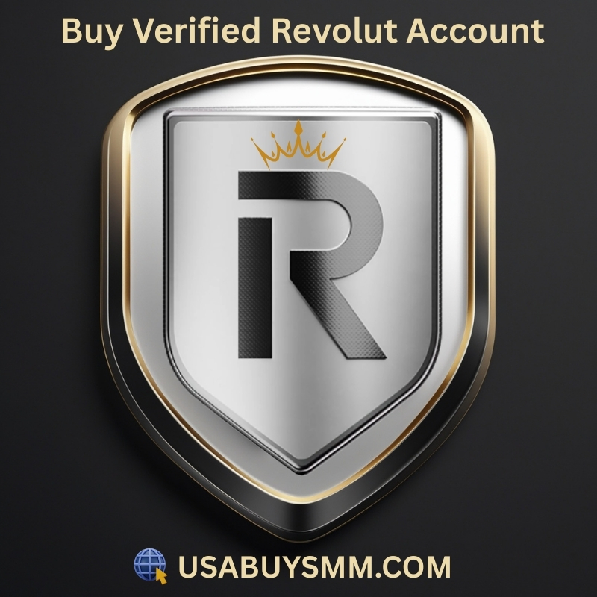

But there’s a growing trend: more people want to **buy verified Revolut accounts** instead of going through the often cumbersome verification process. Whether you're an entrepreneur needing quick international payments or someone looking for anonymity and convenience, a verified Revolut account can be a game-changer.

➤Telegram: usabuysmm

➤WhatsApp: +1 9292439320

➤Website: usabuysmm.com

➤Email: usabuysmm@gmail.com

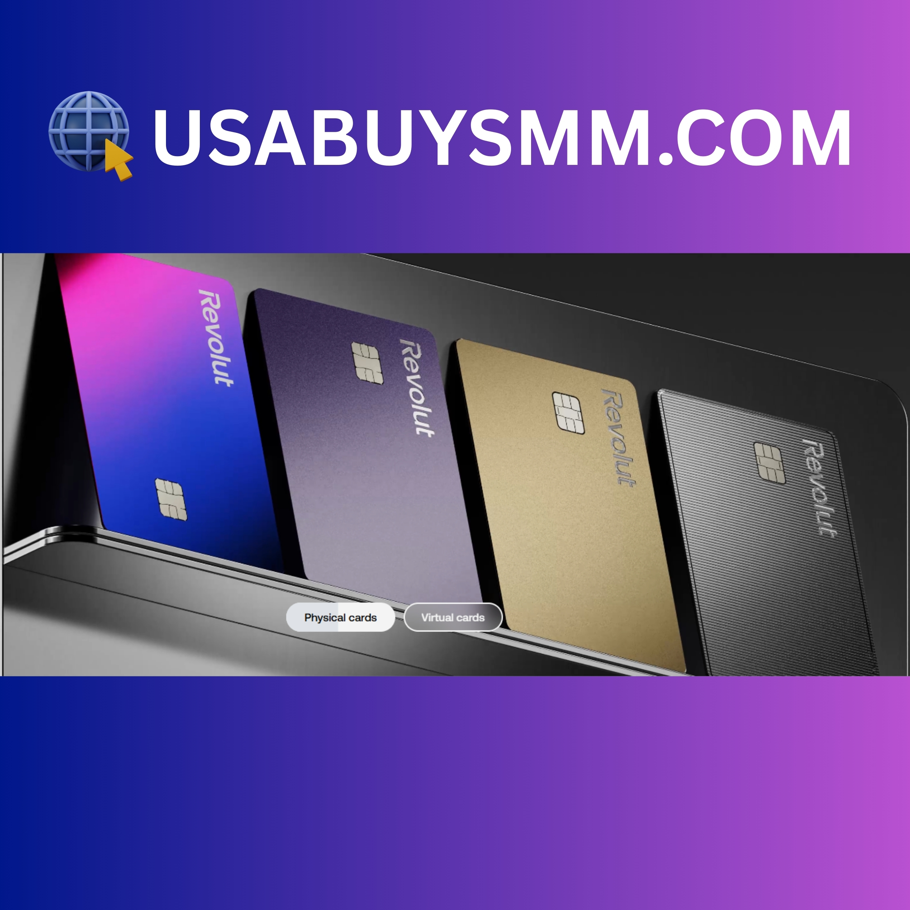

**What Is Revolut and Why Is It in Demand?**

Revolut is not just a mobile banking app—it’s a full-fledged financial ecosystem. It offers currency exchange, virtual cards, crypto trading, budgeting tools, and international banking without the red tape of traditional banks. It appeals to digital nomads, freelancers, and even companies expanding globally.

**How Revolut Transformed Digital Banking Globally**

With real-time currency conversion, low fees, and multi-currency accounts, Revolut revolutionized banking. In emerging markets and the gig economy, having a Revolut account means better control of money and the ability to transact in USD, EUR, GBP, and more with just a few taps.

**Understanding Verified Revolut Accounts**

**What Does a “Verified” Revolut Account Mean?**

A verified Revolut account is one that has passed the Know Your Customer (KYC) checks. This includes identity verification through ID documents, selfies, and sometimes address verification. A verified account unlocks full functionality—such as increased transfer limits, access to crypto and stocks, and global transfers.

**Key Features of a Fully Verified Account**

* Higher monthly transfer limits
* Access to cryptocurrency trading
* Virtual and physical cards
* Full customer support access
* Global money transfers

These features are especially appealing for users who want instant access to Revolut’s full suite without delays.

**Reasons to Buy a Verified Revolut Account**

**Faster Access to Financial Services**

Buying a pre-verified Revolut account means skipping the entire KYC process. For those who need immediate access for business or investment reasons, this saves days, even weeks.

**Avoiding the Hassle of KYC Verification**

The KYC process can be strict. If your ID is expired, you’ve moved countries, or have no proof of address, getting verified can be tough. A bought account eliminates this roadblock.

**Global Transactions and Multi-Currency Use**

Verified Revolut accounts support transactions in 30+ currencies. Digital entrepreneurs often need these to operate in multiple countries efficiently.

**Security and Trust Benefits**

A verified account is less likely to face restrictions or get flagged by Revolut’s risk system, making it a safer long-term asset—if handled properly.

**Legal and Ethical Considerations**

**Is It Legal to Buy a Verified Revolut Account?**

Technically, no. Revolut’s terms prohibit account transfers or sales. However, enforcement is inconsistent, and many users still buy accounts without issue—though it’s a risk.

**Terms of Service: What You Should Know**

Buying or selling Revolut accounts violates their terms. If caught, Revolut can permanently ban or freeze the account.

**Risks of Account Suspension or Bans**

If Revolut suspects unusual login locations, mismatched IPs, or suspicious transactions, they may freeze your account—especially if you didn’t change account details properly.

**Where to Buy a Verified Revolut Account Safely**

**Trusted Marketplaces and Brokers in 2025**

Some dark web marketplaces and Telegram channels claim to offer “fully legit” verified Revolut accounts. However, your safest bet is through brokers with verified reviews and encrypted payment systems.

**How to Identify Scams and Fake Sellers**

Look for:

* Encrypted chat platforms (e.g., ProtonMail, Signal)
* Reviews from real users (check Trustpilot clones and forums)
* Red flags like asking for payment via gift cards or crypto without escrow

**Payment Methods and Transaction Tips**

Always use escrow services. Avoid direct crypto transfers unless you trust the seller. Never give your real identity until you’ve secured access to the account.

**Red Flags and Common Scams to Avoid**

**Warning Signs You’re Dealing With a Fraud**

When trying to **buy verified Revolut account**, scams are abundant. Here are common red flags to watch out for:

* **Too-good-to-be-true pricing** (e.g., $10 for a fully verified account)
* **No escrow or middleman service**
* **Generic screenshots or testimonials**
* **Pushy sellers insisting on immediate payment**
* **Refusal to offer login test or proof**

If any of these red flags show up, walk away immediately.

**How to Report Suspicious Listings**

If you stumble upon a scam or illegal account seller, report the activity to:

* Revolut’s official support channel
* Local cybercrime unit
* Marketplace or platform admins (e.g., Telegram mods)

Protecting others in the community starts with speaking up.

**Comparing the Cost: Buying vs. Creating an Account**

**Hidden Fees You Should Know About**

When you **buy verified Revolut account**, the sticker price might not be the final cost. Consider:

* **Escrow service charges** (3%–10%)
* **Crypto transaction fees**
* **Account recovery costs** (in case it’s locked or banned)
* **Re-verification** (if Revolut requests updated ID)

**Is Buying Worth the Price?**

While creating a Revolut account is free, verification hurdles make it impractical for many users—especially in countries with limited documentation systems. For those who need instant functionality, the cost of buying may be worth the speed and access.

However, always weigh the **risk-to-reward ratio** and consider long-term viability.

**Tips for Using a Bought Revolut Account Safely**

**Changing Login Credentials and Details**

Once you gain access:

1. **Change the email and password immediately.**
2. **Enable two-factor authentication (2FA).**
3. **Update your recovery options (phone, security questions).**

This reduces the chance of the original owner reclaiming the account.

**How to Keep the Account Secure Post-Purchase**

* Avoid logging in from suspicious locations (use VPNs wisely)
* Do not link suspicious cards or bank accounts
* Maintain consistent usage patterns
* Avoid large sudden transactions which might flag Revolut’s systems

These steps help prevent account freezes or investigations.

**Alternatives to Buying a Verified Revolut Account**

**Using Online ID Verification Services**

Several agencies now help users pass KYC by guiding them through legal documentation processes. They offer help with:

* Digital notarization
* Fast-tracked ID generation
* Global residency documents

This can be a safer and more ethical alternative.

**Seeking Help from Legitimate Revolut Agents**

Contact Revolut directly if you’re facing KYC issues. While slow, they sometimes offer manual verifications or accept alternative documents.

Also, you can use Revolut’s community forums to seek advice from users who faced similar problems.

**FAQs About Buying Verified Revolut Accounts**

**Q1: Can I legally own an account that someone else verified?**  
*A1: No, Revolut terms prohibit transferring ownership. You're at risk of ban or account closure.*

**Q2: How much does a verified Revolut account cost?**  
*A2: Prices range from $50 to $300 depending on the features, age, and seller reputation.*

**Q3: Can Revolut detect that I bought an account?**  
*A3: Yes, especially if there’s a sudden change in IP, device, or account behavior.*

**Q4: What happens if the account gets banned after I buy it?**  
*A4: There is usually no recourse unless your seller offered a guarantee or refund clause.*

**Q5: Is there a safe escrow system for these purchases?**  
*A5: Some forums and dark markets offer escrow services. Research carefully before choosing one.*

**Q6: What alternatives exist if I can’t verify my identity?**  
*A6: Try ID support services or digital KYC agencies that offer assistance with compliant document creation.*

**Conclusion: Is It Really Worth It in 2025?**

Buying a verified Revolut account is a shortcut that offers convenience, speed, and access to high-demand financial tools—especially for users who can't pass KYC or need accounts urgently. But it's a path filled with legal gray areas, high risks, and potential for scams.

If you must go this route, **do so cautiously, protect your identity**, and always prioritize security. Consider ethical alternatives first, like ID assistance services, before purchasing from unverified brokers.